125 130th St SE, Everett WA 98208
Phone: 425-224-8200 Fax: 425-224-8299
www.nwwls.com

Patient Name ___________________________________
Phone Number __________________________________
Diagnosis ______________________________________

Services:

- Surgical Weight Loss
- Medical Weight Loss
- Therapeutic Counseling
- Nutrition Education &
Counseling
- Diabetes Education
- Nicotine Cessation
- Exercise Consult
- Heart Rate Testing
- Wellness Program
- Body Composition
Analysis
- Metabolic Rate Testing

Comments _____________________________________
Referring Provider _______________________________
Phone Number __________________________________
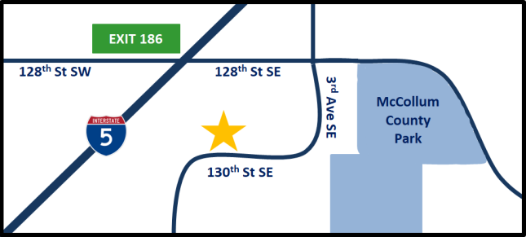
We are located in South Everett just off I-5 on exit 186.

